Chapter 18, Problem 5.

Obtain the Fourier transform of the signal shown in Fig. 18.30.

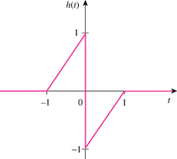

Figure 18.30
For Prob. 18.5.

